Regional Early Action Planning Grants of 2019 (REAP) Close Out Report Form

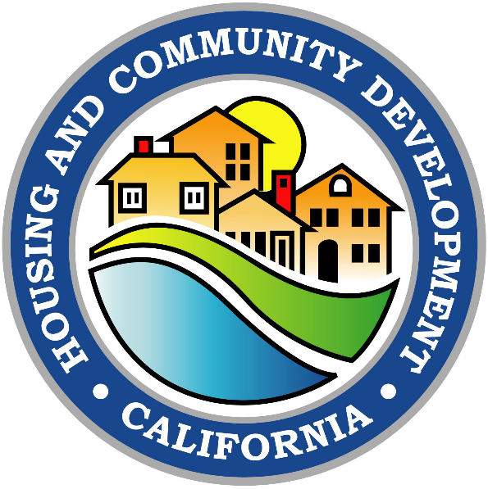
(Grantee Name)
(Date)

REAP Close Out Report Form Instructions
This form is for Regional Early Action Planning Grants of 2019 (REAP) grant holders to satisfy the reporting requirements of California Health and Safety Code section 50515.04. The report must be submitted to the California Department of Housing and Community Development (HCD) via email to reap@hcd.ca.gov no later than December 31, 2025.
Additional information about the REAP program is found at the program’s webpage at:
https://www.hcd.ca.gov/grants-and-funding/programs-active/regional-early-action-planning-grants-of-2019
Please proceed to the REAP Close Out Report Form on the next page and complete Parts I–X.

REAP Close Out Report Form

Part I – Summary
Briefly describe the grantee’s REAP project(s), including but not limited to the following information:
- Overview of the project
- Project start date, duration and completion
- Project goals and relevance to REAP goals
- Proposed uses and actions taken in support of proposed uses
- Actions that had the greatest impact on housing production
- Overall outcomes including quantified outcomes

Click here to enter text.

Part II – Lead Agency and Partnerships
List lead agency and partnerships, including names, position titles, organizations, and the roles and responsibilities of each. What did those collaborative relationships and processes look like?

Click here to enter text.

Part III – Drivers
Answer the following questions:
- Did any local, state, or federal legislation or mandates drive the project(s)? (SB 35, AB 1397, etc.)
- Was it a community-driven effort?
- Were there additional funding opportunities present?

Click here to enter text.

Part IV – Engagement Process
Answer the following questions:
- Who were your stakeholders?
- What did the engagement process look like?
- What role did stakeholders play in the process? (Keep in mind: training, education, council formation, technical assistance, etc.)
- What were the outcomes of the engagement process?

Click here to enter text.

Part V – Challenges
Answer the following questions:
- What challenges were encountered?
- What solutions were encountered or created?
- Are there areas for improvement of policy alignment at the state or federal level to help achieve this project more easily?

Click here to enter text.

Part VI – Outcomes
Answer the following questions:
- What are the current or projected outcomes? What are the benefits?
- Did actual outcomes meet expectations?
- Have new opportunities arisen as a result of this project?
- What are the next steps?

Click here to enter text.

Part VII – Replicability
Answer the following questions:
- What aspects of the project could be replicated in other communities?
- What useful resources and tools were implemented? Were there specific tools used for specific regions or sectors?

Click here to enter text.

Part VIII – Project Highlights, Best Practices and Anticipated Achievements
Answer the following questions:
- What are the most prominent project highlights and why?
- What are some of the best practices that could be used by other agencies at a local, regional, state or federal level?
- What are some long-term achievements that could result from the overall project?

Click here to enter text.

Part IX – Additional Resources
Provide web links to:
- the project itself, and
- resources used throughout the project, and any other relevant resources.

Click here to enter text.

Part X – Further Information
Provide information on who can be reached for HCD to obtain more information about the project. Include names, phone numbers, and email addresses for one or more individuals.

Click here to enter text.

