Heritage Project #1: Reconstruction of National Register Listed Niagara Trestle
Justification: Niagara Camp and Trestle were a part of the West Side Lumber Company Railway System that operated within the Stanislaus National Forest from the early 1900s until late 1950s. The Niagara Trestle was building 1923-1924 and measured 318 feet long and 54 feet high. It was listed on the National Register of Historic Places in 1975 (see attached). The entire camp and trestle were lost during the Rim Fire.
What: Reconstruction of the historic railroad trestle.
Actions: Engineered reconstruction plans, Prepare construction contract, Administer contract, Specialized timber, Installation of new trestle and interpretive panels.
Who: Independent Contractor
Time Frame: 2 years
Cost: Based on reconstruction plans for its sister Trestle (Bourland Trestle) from 2000 (see attached) and considering inflation cost is approximately $1,443,176.00
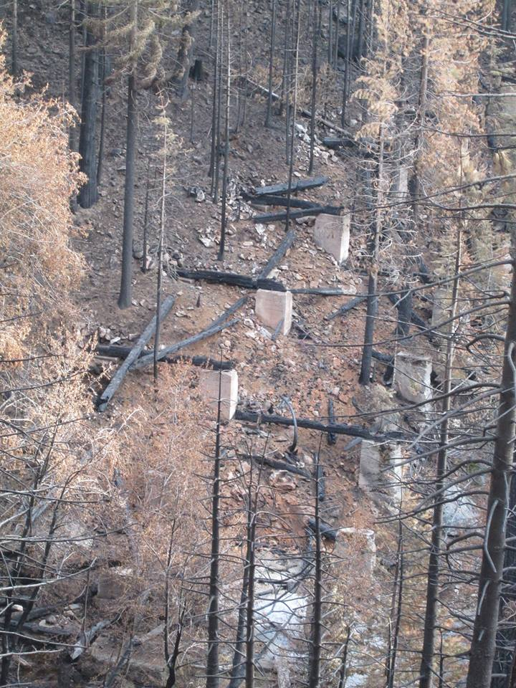
Trestle after fire.

