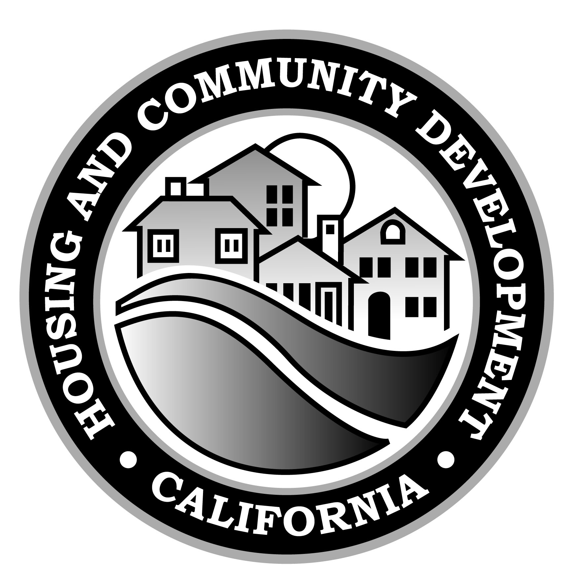

Housing-Related Parks Program

Final Grant Report and Closeout Certification

Contractor: _______________________________ Contract No.: ___-HRPP-_______
Address: _____________________________________________________________
Contact Name: _______________________ Title: ___________________________
E-mail: ______________________________ Phone: _________________________
Contract Dollar Amount : $ __________________

- Capital Asset Acquisitions and Project Descriptions

- For all capital assets acquired or rehabilitated in whole or in part with HRP Program funds, please include the project name as detailed in the Scope of Work (Exhibit A) of the Standard Agreement, a description of the capital asset acquired or rehabilitated and the total amount HRP Program funds used (attach additional sheets if necessary).

Project Name | Capital Asset | Total Cost | HRP Funds Expended Relative to Total Cost

HRP Program Final Closeout Report
Page 2

- Please attach, on a separate sheet, a complete narrative for each project funded in whole or in part with HRP Program funds. The narrative must include, at a minimum, the following information for each project outlined in Section A1 above:
- Project description; and
- Description of the community benefit provided by the project

B. Certifications (Pursuant to Health & Safety Code Section 50544):

Total number of eligible residential units recorded during the eligible year(s) as provided in HRP application:  **Please contact your HRP Program Representative to verify unit information |  |  | Total number of eligible residential units that have been issued a Certificate of Occupancy or Notice of Completion:
Extremely Low-Income | Very Low-Income | Low-Income | Extremely Low-Income | Very Low-Income | Low-Income

C. Closeout Certification:

I hereby certify that all activities undertaken by the _____________________________ (name of Grantee) with funds provided under the HRP Program Standard Agreement have, to the best of my knowledge, been carried out in accordance with the agreement; that proper provision has been made by the Grantee for the payment of all costs and claims; that the State of California is under no obligation to make further payment to the Grantee under the grant agreement; and that every statement and amounts set forth in the Final Grant Cash Request and this Final Grant Closeout Report are, to the best of my knowledge, true and correct. In addition, City/County agrees to retain all records which disclose the activities funded by the Grant including adequate documentation of each transaction for a period of 3 years after the final payment under the Standard Agreement.

Name of Authorized Representative _____________________________________
Title of Authorized Representative _____________________________________
Signature _______________________________ Date __________________

For HCD Use Only
Program Representative_____________________ Approval Date ______________
Program Manager _________________________ Approval Date ______________

Please submit completed form to:
Department of Housing & Community Development
Attn: HRP Program Staff
2020 West El Camino Avenue, Suite 500
Sacramento, CA 95833

HRPP Final Grant Report and Closeout Certification Instructions

The Final Grant Report and Closeout Certification is due within 60 days from the date final grant funds are expended and no later than 60 days after the termination of the Standard Agreement (i.e. no later than 9/30/2016 for DPYs 2010, 2011, and 2013).

- Capital Asset Acquisitions and Project Costs

Section 1. Capital Asset Acquisitions
This section must include all capital assets purchased or rehabilitated with any amount of HRP Program funds, including any equipment or allowable soft costs, such as legal expenses or design work. This section should also include the project name (as indicated in Exhibit A of the Standard Agreement), a description of the capital asset, total amount of HRPP funds expended and total cost of the project (see example below). SEE EXAMPLE BELOW
Project Name | Capital Asset | Total Cost | HRP Funds Expended Relative to Total Cost
River City Park Renovation | Re-roof Community Center | $98,000 | $74,000
River City Park Renovation | New playground equipment | $8,000 | $8,000

Project Categories are as follow (please mark all that apply):
1) Tangible physical property; 2) Maintenance, reconstruction, rehabilitation, demolition for purposes of reconstruction of facilities 3) Equipment (useful life of 5 or more years); 4) Eligible soft costs directly related to the construction, rehabilitation or acquisition of a capital asset project

Section 2. Project Narrative
The Grantee must include a summary of each project funded in whole or in part with HRP Program funds. The summary must include a description of each project, such as the location, scope of the project, and the community benefit achieved from the project. If available, please submit diagrams or renderings, or before and after pictures of each project. Pictures may be submitted with the Final Report or emailed (if digital) to your HRP Program representative.

- Certifications

Table 1: Certificates of Occupancy
The total number of eligible residential units affordable to very low and low income households should be the same as indicated in the HRP Program application as submitted to the Department, or, if applicable, as recalculated by HCD. The final closeout report letter, mailed to grantees once all available funds have been requested from the Department will include information on the total number of units used in calculating the award to be entered in this field. Grantees may also contact their HRP Program representative to verify the number on file with HCD.

This table must also include the total number of certificates of occupancy or notices of completion ultimately issued for eligible units documented during the calendar year(s) covered by the application and used to calculate the final HRP Program award. HCD does not require that documentation of certificates of occupancy or notices of completion be included with this report.

- Closeout Certification
The Final Grant Report and Closeout Certification must be signed by the Authorized Representative as indicated in the contract resolution certified by the Grantee governing body.

