Tribal Homeless Housing, Assistance and Prevention

Grant Program (Tribal HHAP)

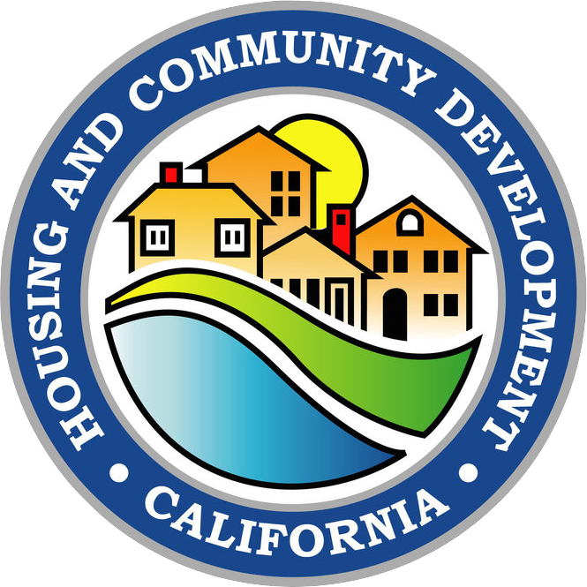

Annual Report

Narrative Section Template

February 28, 2025

[TribalHHAP@hcd.ca.gov](mailto:TribalHHAP@hcd.ca.gov)

**Purpose of Document**

We are providing this template as a tool for copying and pasting your work into the Cognito system. As tribes continue to fulfill their reporting responsibilities, the Cognito system has served as the primary platform for documenting and tracking progress, successes, and budget benchmarks. This document is designed to assist in preparing the narrative section of the report.

To streamline the reporting process, you may use the copy-and-paste function of this Word document to transfer your narrative or bullet points into the Cognito platform. Each Tribal HHAP grant for each separate round will have their own Annual Report submitted in Cognito.

If you have any questions or comments, please reach out to the HCD Tribal HHAP team at [TribalHHAP@hcd.ca.gov](mailto:TribalHHAP@hcd.ca.gov).

**Note:** This document includes only the narrative portion of the Annual Report.

**Important:** This Word document does not need to be submitted.

**The Narrative portion of the Annual Report starts in Section 6:**

**Outcomes**

*Instructions*

Please answer the following questions in narrative or bullet-point format.

1. What have you accomplished with THHAP Round # funds this past year? How have these funds helped your community? Please provide stories of accomplishments of success in your community of a project, individual/family or program. Names and any personal details will be kept confidential. *

Click or tap here to enter text.

1. How are you measuring THHAP Round # success? What tolls are the Tribe using to measure outcomes and track engagements? For example, is the Tribe using trauma informed case management techniques, what are your homeless to housing numbers, what are the dollars spent per individual? *

Click or tap here to enter text.

1. Provide us with a list of your partners and the role they are playing in your THHAP Round # project or program, if applicable. *

Click or tap here to enter text.

**Challenges**

*Instructions*

Please answer the following question in narrative or bullet-point form.

1. Share any challenges or areas where you have experienced setbacks or obstacles while implementing or operating your THHAP Round # project or program (for example: permits, city, county, PG&E, utilities, water districts, responsiveness rate of individuals). *

Click or tap here to enter text.

**Opportunities**

*Instructions*

Please answer the following questions in narrative or bullet-point form.

1. As HCD works in partnership with California Tribal Nations to prevent and eliminate homelessness, where do you believe that THHAP funds can benefit your Tribe in the future? *

Click or tap here to enter text.