2025 Tribal Homeless Housing, Assistance and Prevention Grants Program,

Round 4 Application Template

Notice of Funding Availability Section 3.1 Application Process and Submission
This template is a document to support the Tribal HHAP Applicant during their application process. This is NOT the actual application, instead it is a replica of what the application questions through the online portal will be.

To submit a Tribal HHAP application, please click on the Cognito Dashboard link on our website to start your application through our online portal: https://www.cognitoforms.com/CaliforniaInteragencyCouncilOnHomelessness/_2025TribalHomelessHousingAssistanceAndPreventionGrantsProgramRound4Application

The deadline to submit final applications is January 16, 2026, at 5:00 PM PDT.

For questions, contact the Tribal HHAP team at TribalHHAP@hcd.ca.gov.

Duplicate of Application Questions Provided Below:

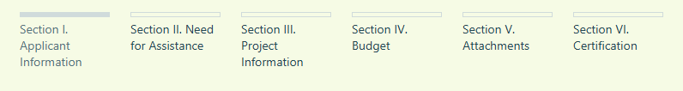

Tribal HHAP – Round 4 Funding
The fourth round of Tribal Homeless Housing Assistance and Prevention (Tribal HHAP-4) Program provides $28.5 million in funding for Federally Recognized Tribes in California to support their efforts to prevent and end homelessness in their communities. Initially, THHAP was administered by the California Interagency Council on Homelessness; however, in accordance with the 2024 Budget Act, the California Department of Housing and Community Development (HCD) began administering the program in July 2024.
Applications are due to HCD no later than 5:00 p.m. on January 16, 2026. Once your application is submitted and reviewed, you will be notified if additional information is needed regarding your project. If you have any questions, please contact Amy Lopez, Tribal HHAP Manager, by email at TribalHHAP@hcd.ca.gov.
Grantees are encouraged to propose culturally appropriate, innovative programs and solutions that meet their needs. Partnerships that include the coordination of services are encouraged.
Funding is flexible, can include a broad range of innovative solutions and can include more than one type of intervention at one time. Examples of eligible uses are authorized by Health & Safety Code, Section 50243(e), and can be found in the Notice of Funding Availability located on the program’s website: Tribal Homeless Housing, Assistance and Prevention (Tribal HHAP) Grants Program | California Department of Housing and Community Development. Tribal HHAP does not require matching funds to receive funding.
All applicants are required to have a plan for the use of funds, outlining how the use of funds will prevent and address homelessness in their communities, and the ability to spend the funding by the spending deadlines. If an applicant needs assistance in the development of homelessness solutions, funding may be utilized to conduct a community needs assessment. Additionally, Tribal HHAP Technical Assistance is available to grantees, including pre-application support. To access Tribal HHAP Technical Assistance, please contact Amy Lopez, Tribal HHAP Manager, by email at TribalHHAP@hcd.ca.gov.
The purpose of the application is to provide background regarding the Tribe's known circumstances and vision for the Tribe in their efforts to prevent and address homelessness.
Please note that responses to questions are not competitively scored. Every Tribe who submits a completed application will be offered an award.
There may be a project that meets the needs of your tribal community that you do not see listed in the NOFA that may still qualify for funding. If you have any questions about allowable uses that are not answered in the NOFA, please contact Amy Lopez, Tribal HHAP Manager, by email at TribalHHAP@hcd.ca.gov.

Section I. Applicant Information
Please complete the contact information for the California Federally Recognized Tribe applying for funding, below.
Name of Federally Recognized Tribe
Applicant will select from the dropdown options through the online portal.
Primary Contact’s Name for this Tribal HHAP Funding Round

Primary Contact’s Title

Address, City, Zip (Mailing Address)

Email Address

Phone

Alternate Contact’s Name

Alternate Contact’s Title

Alternate Contact’s Email Address

Alternate Contact Telephone Number

Additional - Alternate Contact’s Name (Optional)

Additional - Alternate Contact’s Email Address

Additional - Alternate Contact Telephone Number

Tribal HHAP is required to request annual reports, per statute. Do you know who will be completing your Tribal HHAP annual reports? If yes, please complete the information below.
Grant Reporting Contact’s Name

Grant Reporting Contact’s Title

Grant Reporting Contact’s Telephone Number

Tribal Chairperson or President’s Name

Tribal Chairperson or President’s Email Address

Tribal Chairperson or President’s Telephone Number

Section II. Need for Assistance
- Please describe your Tribe’s need for homelessness programs and/or services.

- Please provide an estimate of the number of people who need the housing and/or homelessness services in your tribal community. (What homelessness looks like in communities may differ; however, may include individuals who are unsheltered, individuals who residing in inhabitable housing conditions, individuals who are “couch surfing,” or something else.)

- How did you determine the need discussed in the previous questions? What available data or information did you use? (For example, community outreach, program data, housing assistance waiting list, or other).

- What does homelessness look like in your community. For example, do you tend to see particular types of homelessness over others, (for example, “couch surfing,” unsheltered homelessness, encampments, or other types of homelessness)?

- What is the current number of tribal members enrolled in your Tribe?

- Tribal HHAP allows Tribes to determine their program eligibility, provided the programs and services are in alignment with the Housing First philosophy, and people served are homeless or at risk of becoming homeless. What populations will be eligible for your programs and services?
- Enrolled Tribal Members
- Native Americans in the Community
- Other: ______________________________________________________
- What is the total number of people in the community you will be serving? For example, if you are limiting services to enrolled tribal members, list the number of enrolled tribal members; if you are providing services to anyone in the community, list the population size of the community. Please provide an estimated number of individuals below.

- In the last three years, what other federal, state, and other resources has your community received to address homelessness?
Resources may include but are not limited to funding from the US Department of Housing & Urban Development (HUD), the California Department of Housing & Community Development (HCD), the California Department of Social Services (CDSS), or previous Tribal HHAP Awards.
Please list each source of funding below and provide additional information about each source of funding in your response, through our online portal.
Please note: If you are a Tribal Designated Housing Entity applying for a Tribe, and you have received funding for multiple Tribes that is also serving this Tribe, please include only what portion of funding you estimate is used for this Tribe’s community members.
If your Tribe has been awarded funds that were frozen or withdrawn/canceled, please do not list that funding.

Funding Source 1
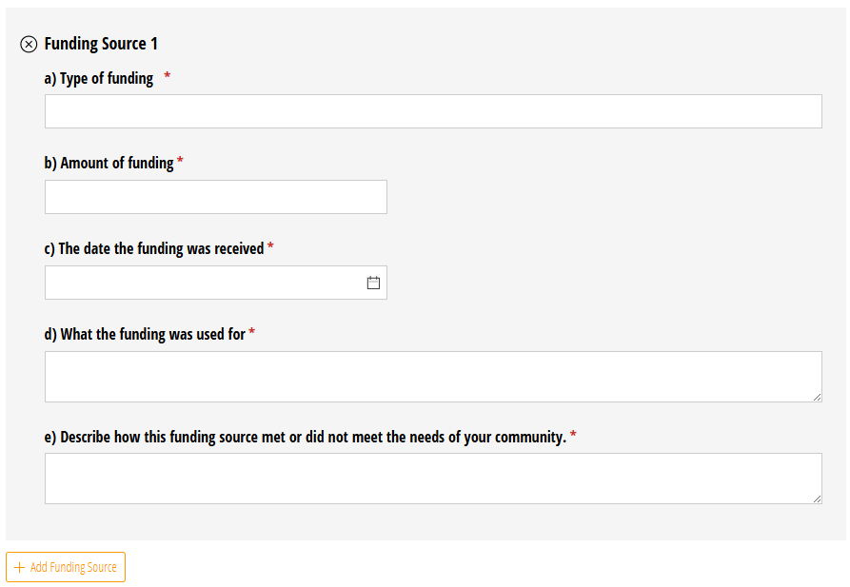

Section III. Project Information
- Every California Federally Recognized Tribe that provides a complete application and enters into contract will receive funding. If your project cannot be fully funded, what programs or services are your highest priority? What are the program or service areas you might plan on eliminating or scaling down from your application?

- Total Tribal HHAP-4 Funds Requested
Please note that Tribal HHAP round 4 does not limit the amount of funds you may request. You are encouraged to request the amount of funds needed for your project(s) to prevent and address homelessness. However, if all the Round 4 requests exceed $28.5 million, an allocation formula based on proportional need will be applied in order to determine award amounts, and every Tribe will not receive their full requested amount.

- Please provide an overview of how your requested funds will be used to prevent and end homelessness in your community. What types of programs and services do you intend on providing with Tribal HHAP funds? Please note that the Tribal HHAP Budget will also request details regarding the intended uses of funding requested. This question requests an overview.

- Do your proposed programs and services include funding in the Interim Shelter or Permanent Housing eligible use categories?
- Yes
- No
If yes, please indicate the estimated number of individuals to be provided interim shelter and the number that will be provided permanent housing over the course of the Tribal HHAP grant, and the source of information for each estimate of individuals to be served. Permanent Housing solutions are encouraged, should adequate funding for such solutions be available. For additional information on what types of programs and services are in each of the eligible use categories, please see Tribal HHAP – 4 Budget Guidance.
Estimated number of individuals to be provided interim shelter:

Source of information:

Estimated number of individuals to be provided with permanent housing:

Source of information:

- If you are building or acquiring new interim shelter or permanent housing options, how many units are you hoping to create? If you are not planning on doing either, please say “N/A” for not applicable.

- Does your Tribe have a history of implementing homelessness/housing grants over $200,000? If not, what are your plans to expand capacity to successfully administer Tribal HHAP funds and ensure all funds are spent by June 30, 2029? Please note that lacking capacity at this time does not disqualify your Tribe from receiving Tribal HHAP funding, and Tribal HHAP funds can be used to build capacity. If assistance is needed to support your program in expanding capacity, culturally responsive technical assistance is available.

- The Tribal HHAP Program requires annual reporting on fiscal project status, narrative descriptions of progress, and aggregate data on the individuals served. What strategies (traditional or otherwise) will you use to measure your program’s success, in addition to the Tribal HHAP reports, if any? (For example, qualitative focus groups, surveys, client interviews, analysis of program data).

- Does your project include partnerships and/or subcontractors?
- Yes – Please provide the names and roles of each partner you intend on working with below.
- No - If you do not plan to work with subcontractors, please explain your Tribe’s capacity to complete all grant activities below.

For example, if you are building a home or building, does your Tribe already have employees dedicated to this work that have capacity – or will you be hiring new employees?
- Who will be responsible for the administration of the project(s) within the Tribe? Please include the name, title and role of each individual, including program, fiscal, and/or other staff involved.

Section IV. Budget
Include your proposed budget in the application by filling out the columns below.
If the total request for funds exceeds $28.5 million available, the Department will determine an allocation methodology based on each applicant’s proportionate share of need relative to all Tribes that applied (HSC section 50241(a)(3)(A).) Should this occur, grantees who do not receive the funds they requested in full will be required to submit a revised budget for the allocated award amount.
This budget is subject to change based on your awarded amount, if a revised budget is required the THHAP team will reach out to the Applicant's contacts.
NOFA Section 2.2 Eligible Uses
Tribal Communities hold the expertise to design and implement culturally responsive solutions that meet the needs of their communities. Applicants are encouraged to apply a culturally appropriate lens to each category, ensuring that programs and services are customized to meet the needs of their population.
The THHAP Round 4 Eligible Use Categories Guidance is available to assist you in determining which programs and/or services fit into each eligible use category for your Tribe.
Please only enter information in the categories in which you are proposing THHAP programs and/or services. You do not need to have funding allocated in each eligible use category.
Under “Activities these funds will support” please provide narrative details on what the funds will be used for under each category selected, (for example, using the funds to hire staff, acquire land, pay rental subsidies, or offer life skills classes, etc.).
Administrative Costs: Per statute, administrative costs are capped at seven percent (7%) of program funds. Administration costs only include overhead costs for the administration of the grant funds. Staff and other costs directly related to carrying out eligible activities are not administrative costs and are considered general program costs.
Proposed Budget:
Eligible Use Category | Total THHAP Round 4 Dollars Budgeted | Activities these funds will support:
Permanent Housing Solutions
Interim Housing Solutions
Homelessness Prevention
Non-Housing Solutions
Administrative Costs
(capped at 7% of total)

Section V. Attachments
NOFA Section 3.1 Application Process - Please include the following through the application portal, (if applicable). Items with an asterisk (*) are required.
- Tribal Resolution* - Please include a Tribal Resolution that includes the following:
a. Approval to apply for Tribal HHAP Round 4.
b. The total amount of Tribal HHAP Round 4 funding requested.
- Government Agency Taxpayer ID Form (GovTIN)* - Please ensure the Tribe name matches the BIA system. The address on the tax form is the address that your check will be mailed to. -- GovTIN Form Link
- Tribe’s Data Sharing Policy or Agreement (if applicable)
- Additional Information may be uploaded, if desired: including, but not limited to Letters of Support, documents related to the planning of desired projects and needs assessments.

Section VI. Certification
On behalf of the Tribe identified in this application, I certify that: The information, statements and attachments included in this application are to the best of my knowledge and belief, true and correct and I possess the Tribe's legal authority to submit this application on behalf of [Applicant Name].
After selecting "Submit" below, the Applicant's contacts will receive an email confirmation from our online Cognito system, confirming the Tribe's application has been submitted.
If the THHAP Team has any follow up questions regarding your application, they will reach out to the Applicant's first and secondary contacts, through the TribalHHAP@hcd.ca.gov inbox.
Title: ______________________________
Date: _____________________________

